Exploring the design space of programmable friction for scrolling interactions

Ultrasound Swipe

【Summary】：

Study swipe gestures for touch screens.

【Apparatus】：

We used a Large Area Tactile Pattern Display (LATPaD) [13], an experimental touchscreen that reduces the fric-tion experienced by a sliding finger on its surface by creating a ‘squeeze film’ of air using imperceptible high-frequency vibration (Figure 1). Vibrations are created by piezoelectric actuators bonded along one side of a glass plate that rests atop an LCD screen, while fingerpad position is measured with a laser-based optical system, resulting in a 57 × 76 mm haptic touchscreen. Tactile effects are produced by altering the amplitude of vibrations, and hence the amount of friction, as the fingerpad slides against the touchscreen.

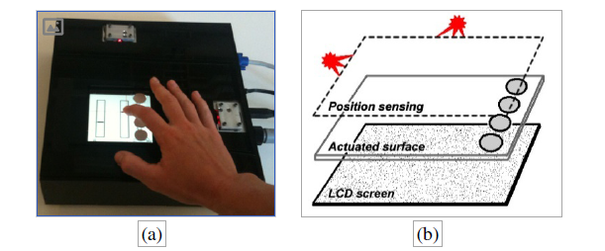

【Contribute】：

**• Scenario 1 – Document navigation with vertical scrolling.** A document is scrolled by dragging its content along the length of the screen. Feel: distinct detents and textures as elements of the document (headers, images, markings) scroll through the screen.

**• Scenario 2 – Video navigation with multi-rate scrubbing.** A stream is navigated by sliding against different horizontal slid-ers, each controlling scrubbing at different rates. Feel: different densities of detents on each slider, indicating the rate; distinctive detents distinguish minor and major tick marks, display anno-tated locations, and indicate transitions between sliders.

**• Scenario 3 – List navigation with circular scrolling.** A long list is navigated with a continuous circular gesture. Feel: rate of flow as a stream of detents; and distinct detents on transitions between groups of items or on marked items.

**• Scenario 4 – List navigation with rate control.** A long list is navigated by engaging a joystick-like controller, with scrolling rate proportional to the pressure applied. Feel: resistance when engaging the spring-like controller.

**• Scenario 5 – Numeric entry with slider.** A numerical value is entered by sliding horizontally against a controller. Feel: dis-tinct detents on minor and major tick marks.

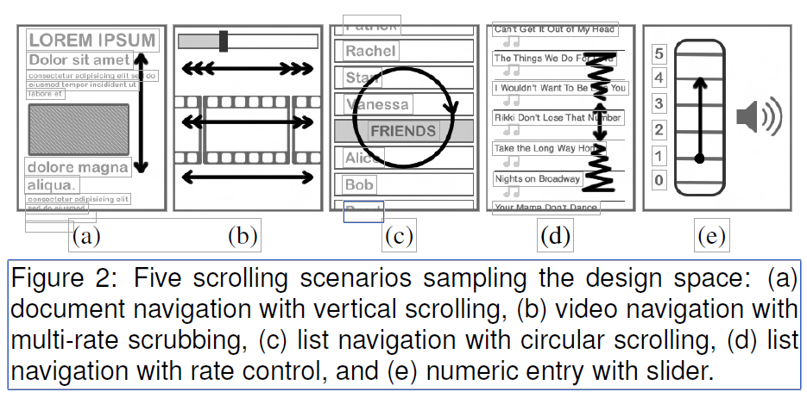

【Experiments】：

the identifiability of a set of six tactile detents (E1); the factors affecting the counting of detent se-quences (E2); the comparability of detent densities (E3); the syn-chronization of tactile feedback to on-screen events (E4); and the most realistic rendering for a spring-like resistance (E5).

【Important Reference】:

1. E. Hoggan, S. A. Brewster, and J. Johnston. Investigating the effec-tiveness of tactile feedback for mobile touchscreens. In Proc. CHI’08, pages 1573–1582, 2008.

[7] B. L. M. Kaaresoja, T. and J. Linjama. Snap-crackle-pop: Tactile feedback for mobile touch screens. In Proc. EuroHaptics’06, pages 565 – 566, 2006.

[9] V. Levesque, L. Oram, K. MacLean, A. Cockburn, N. D. Marchuk,D. Johnson, J. E. Colgate, and M. A. Peshkin. Enhancing physicality in touch interaction with programmable friction. In Proc. CHI’11, pages 2481–2490, May 2011.

[13] N. D. Marchuk, J. E. Colgate, and M. A. Peshkin. Friction measure-ments on a large area TPaD. In Proc. Haptics Symposium 2010, pages 317 –320, 2010.

[17] J. Pasquero, J. Luk, V. L´evesque, Q. Wang, V. Hayward, and K. E. MacLean. Haptically enabled handheld information display with distributed tactile transducer. IEEE Transactions on Multimedia, 9(4):746–753, 2007.

[18] I. Poupyrev and S. Maruyama. Tactile interfaces for small touch screens. In Proc. UIST’03, pages 217–220, 2003.

[23] B. A. Swerdfeger, J. Fernquist, T. W. Hazelton, and K. E. MacLean. Exploring melodic variance in rhythmic haptic stimulus design. In Proc. GI’09, pages 133–140, 2009.